LIVER CANCER



**Liver cancer is cancer that begins in the cells of your liver. Your liver is a football-sized organ that sits in the upper right portion of your abdomen, beneath your diaphragm and above your stomach.**

**Several types of cancer can form in the liver. The most common type of liver cancer is hepatocellular carcinoma, which begins in the main type of liver cell (hepatocyte).**

**Cancer that spreads to the liver is more common than cancer that begins in the liver cells. Cancer that begins in another area of the body — such as the colon, lung or breast — and then spreads to the liver is called metastatic cancer rather than liver cancer. This type of cancer is named after the organ in which it began — such as metastatic colon cancer to describe cancer that begins in the colon and spreads to the liver.**

**What are the symptoms?**

**Most people don’t have signs and symptoms in the early stages of primary liver cancer. When signs and symptoms do appear, they may include:**

* **Losing weight without trying**
* **Loss of appetite**
* **Upper abdominal pain**
* **Nausea and vomiting**
* **General weakness and fatigue**
* **Abdominal swelling**
* **Yellow discoloration of your skin and the whites of your eyes (jaundice)**
* **White, chalky stools**

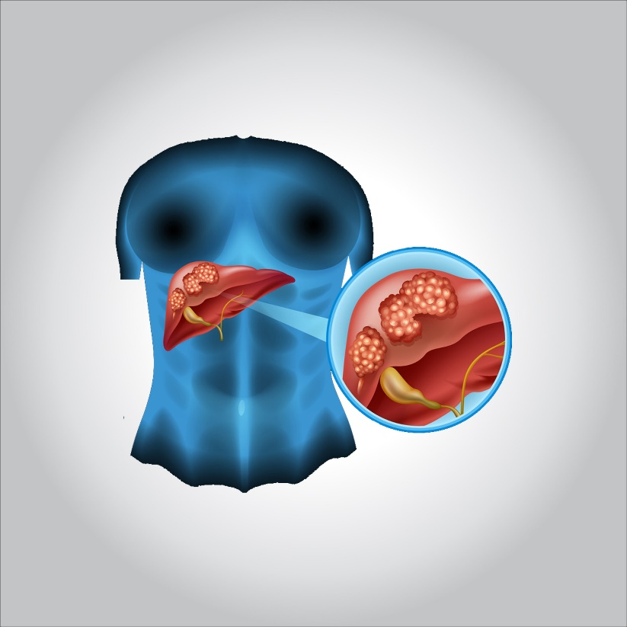

**What are the causes?**

**Liver cancer happens when liver cells develop changes (mutations) in their DNA. A cell’s DNA is the material that provides instructions for every chemical process in your body. DNA mutations cause changes in these instructions. One result is that cells may begin to grow out of control and eventually form a tumor — a mass of cancerous cells.**

**Sometimes the cause of liver cancer is known, such as with chronic hepatitis infections. But sometimes liver cancer happens in people with no underlying diseases and it’s not clear what causes it.**

**Risk factors**

**Factors that increase the risk of primary liver cancer include:**

* **Chronic infection with HBV or HCV. Chronic infection with the hepatitis B virus (HBV) or hepatitis C virus (HCV) increases your risk of liver cancer.**
* **Cirrhosis. This progressive and irreversible condition causes scar tissue to form in your liver and increases your chances of developing liver cancer.**
* **Certain inherited liver diseases. Liver diseases that can increase the risk of liver cancer include hemochromatosis and Wilson’s disease.**
* **Diabetes. People with this blood sugar disorder have a greater risk of liver cancer than those who don’t have diabetes.**
* **Nonalcoholic fatty liver disease. An accumulation of fat in the liver increases the risk of liver cancer.**
* **Exposure to aflatoxins. Aflatoxins are poisons produced by molds that grow on crops that are stored poorly. Crops, such as grains and nuts, can become contaminated with aflatoxins, which can end up in foods made of these products.**
* **Excessive alcohol consumption. Consuming more than a moderate amount of alcohol daily over many years can lead to irreversible liver damage and increase your risk of liver cancer.**

**What is the prevention?**

**Reduce your risk of cirrhosis**

**Cirrhosis is scarring of the liver, and it increases the risk of liver cancer. You can reduce your risk of cirrhosis if you:**

* **Drink alcohol in moderation, if at all. If you choose to drink alcohol, limit the amount you drink. For women, this means no more than one drink a day. For men, this means no more than two drinks a day.**
* **Maintain a healthy weight. If your current weight is healthy, work to maintain it by choosing a healthy diet and exercising most days of the week. If you need to lose weight, reduce the number of calories you eat each day and increase the amount of exercise you do. Aim to lose weight slowly — 1 or 2 pounds (0.5 to 1 kilograms) each week.**

**Get vaccinated against hepatitis B**

**You can reduce your risk of hepatitis B by receiving the hepatitis B vaccine. The vaccine can be given to almost anyone, including infants, older adults and those with compromised immune systems.**

**Take measures to prevent hepatitis C**

**No vaccine for hepatitis C exists, but you can reduce your risk of infection.**

* **Know the health status of any sexual partner. Don’t engage in unprotected sex unless you’re certain your partner isn’t infected with HBV, HCV or any other sexually transmitted infection. If you don’t know the health status of your partner, use a condom every time you have sexual intercourse.**
* **Don’t use intravenous (IV) drugs, but if you do, use a clean needle. Reduce your risk of HCV by not injecting illegal drugs. But if that isn’t an option for you, make sure any needle you use is sterile, and don’t share it. Contaminated drug paraphernalia is a common cause of hepatitis C infection. Take advantage of needle-exchange programs in your community and consider seeking help for your drug use.**
* **Seek safe, clean shops when getting a piercing or tattoo. Needles that may not be properly sterilized can spread the hepatitis C virus. Before getting a piercing or tattoo, check out the shops in your area and ask staff members about their safety practices. If employees at a shop refuse to answer your questions or don’t take your questions seriously, take that as a sign that the facility isn’t right for you.**

**Seek treatment for hepatitis B or C infection**

**Treatments are available for hepatitis B and hepatitis C infections. Research shows that treatment can reduce the risk of liver cancer.**

**Ask your doctor about liver cancer screening**

**For the general population, screening for liver cancer hasn’t been proved to reduce the risk of dying of liver cancer, and it isn’t generally recommended. People with conditions that increase the risk of liver cancer might consider screening, such as people who have:**

* **Hepatitis B infection**
* **Hepatitis C infection**
* **Liver cirrhosis**

**Discuss the pros and cons of screening with your doctor. Together you can decide whether screening is right for you based on your risk. Screening typically involves a blood test and an abdominal ultrasound exam every six months.**

**Treatment**

**Treatments for primary liver cancer depend on the extent (stage) of the disease as well as your age, overall health, and personal preferences.**

**Surgery**

**Operations used to treat liver cancer include:**

* **Surgery to remove the tumor. In certain situations, your doctor may recommend an operation to remove the liver cancer and a small portion of healthy liver tissue that surrounds it if your tumor is small and your liver function is good.**

**Whether this is an option for you also depends on the location of your cancer within the liver, how well your liver functions and your overall health.**

* **Liver transplant surgery. During liver transplant surgery, your diseased liver is removed and replaced with a healthy liver from a donor. Liver transplant surgery is only an option for a small percentage of people with early-stage liver cancer.**

**Localized treatments**

**Localized treatments for liver cancer are those that are administered directly to the cancer cells or the area surrounding the cancer cells. Localized treatment options for liver cancer include:**

* **Heating cancer cells. Radiofrequency ablation uses electric current to heat and destroy cancer cells. Using an imaging test as a guide, such as ultrasound, the doctor inserts one or more thin needles into small incisions in your abdomen. When the needles reach the tumor, they’re heated with an electric current, destroying the cancer cells. Other procedures to heat the cancer cells might use microwaves or lasers.**
* **Freezing cancer cells. Cryoablation uses extreme cold to destroy cancer cells. During the procedure, your doctor places an instrument (cryoprobe) containing liquid nitrogen directly onto liver tumors. Ultrasound images are used to guide the cryoprobe and monitor the freezing of the cells.**
* **Injecting alcohol into the tumor. During alcohol injection, pure alcohol is injected directly into tumors, either through the skin or during an operation. Alcohol causes the tumor cells to die.**
* **Injecting chemotherapy drugs into the liver. Chemoembolization is a type of chemotherapy treatment that supplies strong anti-cancer drugs directly to the liver.**
* **Placing beads filled with radiation in the liver. Tiny spheres that contain radiation may be placed directly in the liver where they can deliver radiation directly to the tumor.**

**Radiation therapy**

**This treatment uses high-powered energy from sources such as X-rays and protons to destroy cancer cells and shrink tumors. Doctors carefully direct the energy to the liver, while sparing the surrounding healthy tissue.**

**Radiation therapy might be an option if other treatments aren’t possible or if they haven’t helped. For advanced liver cancer, radiation therapy might help control symptoms.**

**During external beam radiation therapy treatment, you lie on a table and a machine directs the energy beams at a precise point on your body.**

**A specialized type of radiation therapy, called stereotactic body radiotherapy, involves focusing many beams of radiation simultaneously at one point in your body.**

**Targeted drug therapy**

**Targeted drug treatments focus on specific abnormalities present within cancer cells. By blocking these abnormalities, targeted drug treatments can cause cancer cells to die.**

**Many targeted drugs are available for treating advanced liver cancer.**

**Some targeted therapies only work in people whose cancer cells have certain genetic mutations. Your cancer cells may be tested in a laboratory to see if these drugs might help you.**

**Immunotherapy**

**Immunotherapy uses your immune system to fight cancer. Your body’s disease-fighting immune system may not attack your cancer because the cancer cells produce proteins that blind the immune system cells. Immunotherapy works by interfering with that process.**

**Immunotherapy treatments are generally reserved for people with advanced liver cancer.**

**Chemotherapy**

**Chemotherapy uses drugs to kill rapidly growing cells, including cancer cells. Chemotherapy can be administered through a vein in your arm, in pill form or both.**

**Chemotherapy is sometimes used to treat advanced liver cancer.**

**Supportive (palliative) care**

**Palliative care is specialized medical care that focuses on providing relief from pain and other symptoms of a serious illness. Palliative care specialists work with you, your family and your other doctors to provide an extra layer of support that complements your ongoing care. Palliative care can be used while undergoing other aggressive treatments, such as surgery, chemotherapy or radiation therapy.**

**When palliative care is used along with all of the other appropriate treatments, people with cancer may feel better and live longer.**

**Palliative care is provided by a team of doctors, nurses and other specially trained professionals. Palliative care teams aim to improve the quality of life for people with cancer and their families. This form of care is offered alongside curative or other treatments you may be receiving.**